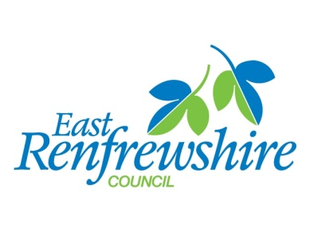

Our Ref:
Your Ref:
Contact: John Shelton
Tel: 0141 577 3142
Fax:
Email: john.shelton@eastrenfrewshire.gov.uk
Date: 10 May 2018
Postcode.. |  | Environment Department  2 Spiersbridge Way  Spiersbridge Business Park  Thornliebank  G46 8NG

Dear Sir / Madam,

East Renfrewshire Tackling Dangerous Junctions Programme; Eastwood Toll (A77/A727) Roundabout & Spiersbridge (A727/B769) Roundabout

East Renfrewshire Council (ERC) will shortly be undertaking a cycling safety review at the Spiersbridge and Eastwood Toll Roundabouts. This is being funded by Sustrans’ Tackling Dangerous Junctions programme.

In June 2016 Sustrans identified 20 junctions across Scotland with the highest number of cycle collisions relative to the level of cycling. Spiersbridge Roundabout was ranked 16th in the top 20 dangerous junctions for cyclists in Scotland. Eastwood Toll Roundabout was ranked just outside the top 20 dangerous junctions but 3rd most dangerous in East Renfrewshire

Given the proximity of the two junctions, ERC are investigating both roundabouts and the connecting A727 corridor collectively. The review will consider:

- Full analysis of cycle accidents over the last five years
- Conceptual design options (which could include potentially reassigning / restructuring the roundabout)
- Appraisal of each of the options identified
- Consideration of any proposed development which would potentially increase the number of future traffic movements on the roundabout
- Traffic surveys conducted at the roundabout to monitor and review the existing number of cyclists using the junction as well as their movements
- Any further appraisal of options prior to end of June 2018 deadline

Instead of an exclusive ‘cycling project’, ERC are keen to investigate options that would also benefit pedestrians and disabled users who may also have difficulty negotiating these junctions.

Given timescales involved we are not planning any formal public consultation. However, if you would like to make any representations we would be open to any comments, feedback or suggestions from potential stakeholders.

Please note that an initial findings review meeting will be held week beginning 4 June. Any representation prior to this date gratefully received. If you would like any more information please contact John Shelton – Green Network Project Officer (john.shelton@eastrenfrewshire.gov.uk – 0141 577 3142)

Yours faithfully,

John Marley
Senior Transportation Coordinator

